Build Design Review

1. **Agenda**

In this build design review, the following topics will be discussed:

* Design changes since CDR or the previous BDR
* Build contents
* Testing strategy
* Changes to remaining builds and releases
* Updated Software size estimates
* Milestones and Schedules
* Issues, risks, problems, and TBD items

1. **Design changes since CDR or the previous BDR**
   1. The overall design of the IoT platform for this project has been constant without major changes. The design of the IoT blocks will still include the rule engine, databases (MySQL), a message broker (MQTT), an API Interface, and a block for Microservices.
   2. Diagram of the IoT platform:

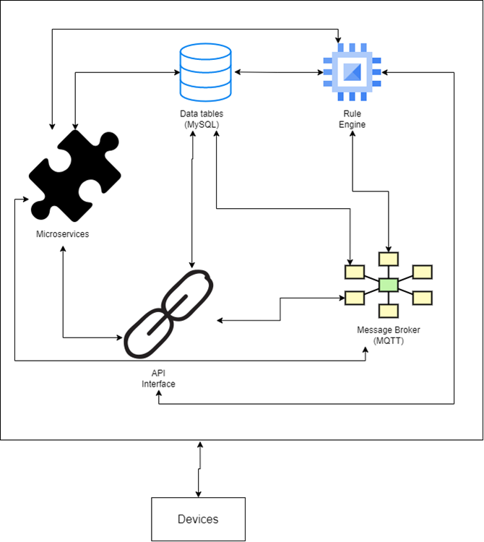

1. **Build contents**
   1. The requirements that must be met for the build is that all the core blocks of the IoT platform are to be functional and operational by the end of testing and build phases.
   2. The core blocks that are to be included in the build are the rule engine, databases, the message broker, and the functional API interface.
   3. Each block will be tested for functionality according to the guidelines in the Test Plan Outline.
   4. As this will be the first build of the platform, there are no unresolved issues from a previous build to be resolved.
2. **Testing strategy**
   1. The Application specialists will create plans to test the functions of the system. The development team will create executables from the source code and test the executable according to the test plan. The management team and the development team review the test results to ensure that all errors are identified and corrected. The development will create user guides and system description documents. The application specialists will create the system test plan and in the independent acceptance test team will use the plan during the acceptance test phase.
   2. The guidelines to determine if the test is successful/failure will be a test without any errors that cause major disturbance in the system. Any minor errors will be documented and corrected when members of the team have extra time. A successful test will include the system in operational stature. If the system is not working or is broken, the test should be considered a failure.
3. **Updated storage and memory size estimates**
   1. The estimated size of required storage space has remained the same at 50GB. This storage space is necessary for housing the IoT platform as well as the required software used to create it.
   2. The estimated size of required memory has remained the same at 2GB of memory.
4. **Milestones and Schedules for the build**
   1. The testing and building of the platform will be done throughout a 2-week schedule. Each week the team will be focused on testing half of the number of the required blocks (Microservices is optional and will be added if time allows).
   2. The first week will focus on testing and building the message broker and databases blocks.
   3. The second week will focus on testing and building the API interfaces and rule engine blocks
   4. For an IoT project of this size, it is believed that 2 weeks of testing these core blocks of the platform would be sufficient.
5. **Issues, risks, problems, and TBD items**
   1. Since there is no previous build of the proposed IoT platform, there are no records of past documented issues or problems that occurred during testing and building of the core blocks. Therefore, we shall expect to encounter issues during the build.
   2. Any issues or problems that occur regarding the platform will be monitored and resolved based on the guidelines provided in the Test Plan Outline